Oslo Model

20th February 2017

Priyanka Mocherla

CID: 00929775

Words:

***This paper focuses on studying the system height and avalanche size for various system sizes, L, using the Oslo Model. The height was measured as a function of time, and separated into transient and recurrent configurations at a cut-off time. The cut-off time varied as L2 whilst the average height scaled with L. Corrections to scaling were present for small system sizes, and correction values determined for the height were a0 = 1.733 and w1 = 0.60. The height probabilities were also plotted and a data collapse performed. Avalanche-size was also investigated to test if it followed the finite scaling ansatz. Two methods were used to calculate the critical exponents tau s and D. The first method involved taking data from the avalanche size probability districution, and gave values of taus = 1.55 and D =2.21. The second method involved moment analysis and gave values of taus = 1.55 and D =2.22. They both values close to the expected 1.55 and 2.25, and the discrepancy s likely to come from a correction to scaling effect present at small system sizes.***

# Introduction

The Oslo model is an algorithm that simulates the response of a pile of grains to a small perturbation of adding a grain. It is based off the ricepile experiment conducted at the University of Oslo, whereby grains of rice were added to a pile and, by measuring the energy change due to perturbation; the self-organised criticality of the system was measured.

This paper studies the Oslo model response to perturbation by analyzing the heights and avalanche-sizes for various system sizes. It will attempt to form data collapses of the system sizes, to discuss the models self-organised nature.

Figure : The general algorithm for the Oslo model. The pile is driven and relaxed for a specified number of grains.

# Theory

The physical system modelled by the Oslo algorithm is a 1D pile of grains, confined between two plates with one closed and one open boundary. The number of sites that the grains can occupy horizontally defines the system size, and there is no upper limit on the pile height. Grains are added one at a time at the first site next to the closed boundary. Once enough grains enter the system, avalanches will occur, whereby an unstable configuration of grains relaxes until it reaches stability. Grains can leave the system through avalanches at the closed boundary. In the Oslo model, this instability produced by introducing a threshold slope, which can trigger avalanches if surpassed after the addition of a grain. The height of the pile is given by the height at site one, and the avalanche size by the number of relaxations the system undergoes after a grain is added before reaching a stable configuration again. This can include avalanche sizes of zero.

# Method

## The Oslo Model Algorithm

The algorithm written to produce the Oslo model is presented in Figure 1. It is repeated until a specified number of grains have been entered into the system. The model itself closely follows the Bak-Tang-Weisenfeld (BTW) model, however it introduces a variable slope threshold of 1 or 2, with equal probability (0.5) of being chosen.

## Testing the algorithm

To confirm that the Oslo model coded for this experiment worked as expected, several tests were conducted. Running the algorithm for 105 grains, the average steady state heights and avalanche sizes were analysed for p = 0.5 and p = 1.0. The summary results are shown in Table 1.

Table 1: The test results for threshold probabilities of 1.0 and 0.5, after running for 105 grains. The average heights, <h>, and avalanche size, <s>, are measured, and the values obtained correspond with theoretical results.

|  |  |  |  |
| --- | --- | --- | --- |
| **Probability** | **System size** | **<h>** | **<s>** |
| 1.0 | 16 | 16.0 | 16.0 |
| 1.0 | 32 | 32.0 | 32.0 |
| 0.5 | 16 | 26.5 | 16.0 |
| 0.5 | 32 | 53.9 | 31.9 |

Setting p = 1.0 forces all slope thresholds to be one, therefore, at steady state, the avalanche-size and the system height should equal the system size, which was confirmed. For p = 0.5, the average heights for L = 16, 32 were known to be approximately 26.5 and 53.9, respectively. Similarly to p = 1.0, the average avalanche size was expected to equal system size, as at steady state, the average number of grains added to the system is equal to the number of grains that leave it. Table 1 shows that these critera was fulfilled; therefore the Oslo algorithm was confirmed to be working correctly.

# Results

## Oslo Model System Height

To investigate the height characteristics of the model, the algorithm was run for 500,000grains, with p =0.5. Unless otherwise stated, all calculations were made when the system was in steady state.

### Average Height

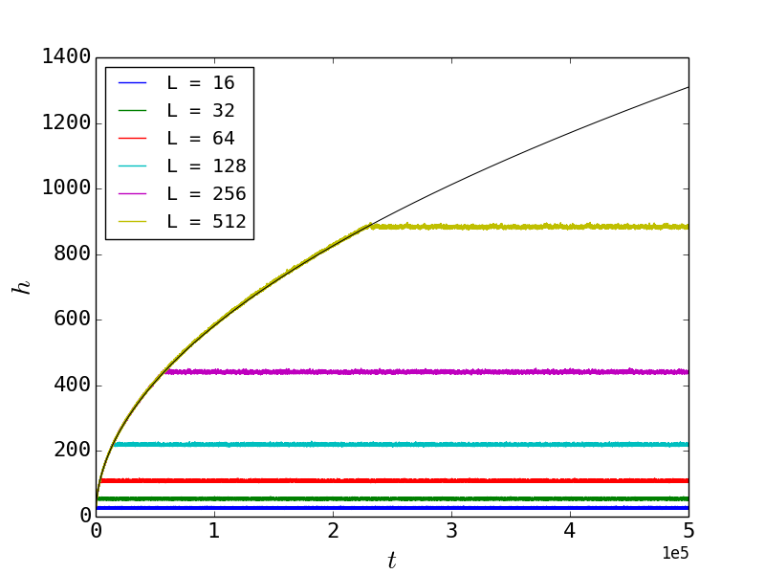

Figure : A plot showing the behavior of height with time and system size. Each curve can be separated into two sections. A transient section, fitted with a black line, and a recurrent section of statistically stationary height. The fitted line varies proportional to t0.50.

Figure 1 presents the height of the system as a function of system size, L. For each L, the curve can be divided into two sets of stable configurations; transient and recurrent. The transient configurations occur as the system starts to fill with grains, and the grains are unaware of the finiteness of L. The transient height is shown to increase following the same power law regardless of L.

After a cut-off time, tc, the system enters a set of recurrent configurations, and is in a statistically stationary state. Both the average steady state height, hc, and tc are shown to have a dependence on L. Therefore by plotting both of these variables as a function of L, the relationship between them can be extracted.

To extract hc, the data was averaged over 250,000 grains. Figure 2 displays the linear relationship between hc and L. To obtain the average slope, the sum of local slopes, must be averaged over all space. As the sum local slopes is equal to the system height, the average slope can be written as:

$$z\left(t;L\right)= \frac{1}{L}h(t;L)$$

where $h\left(t;L\right)$ is the height of the pile. For a constant slope, the maximum height of the system at any given time scales linearly with L, and therefore it can explain the relationship presented in Figure 3.

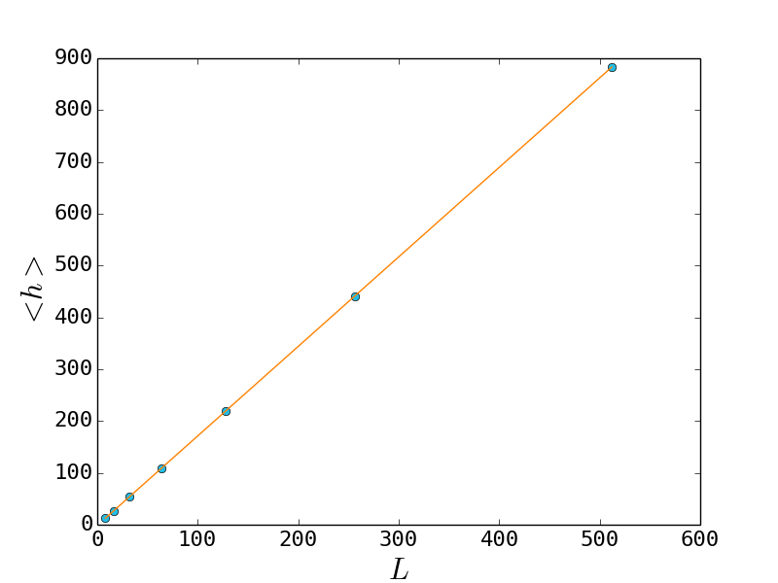

Figure 3: A graph showing the relationship between average height and system size. The height scales linearly with system size.

For each system, tc was calculated by finding the point of intersection between the fitted transient curve and the average steady state height. Figure 3 presents the data obtained.

From the logarithmic plot, tc is shown to follow a power law, and by measuring the gradient of the data, it is found that tc scales as L2. This corroborates with theoretical prediction if the critical time is taken to be the total number of grains added to the system before the first grain leaves. At this critical point, the number of grains added could be approximated to the area taken by the grains, which in fact is given by ½ hL, where h is the steady state height. As it was previously found that the height scaled linearly with the system size, the critical time therefore is proportional to L2.

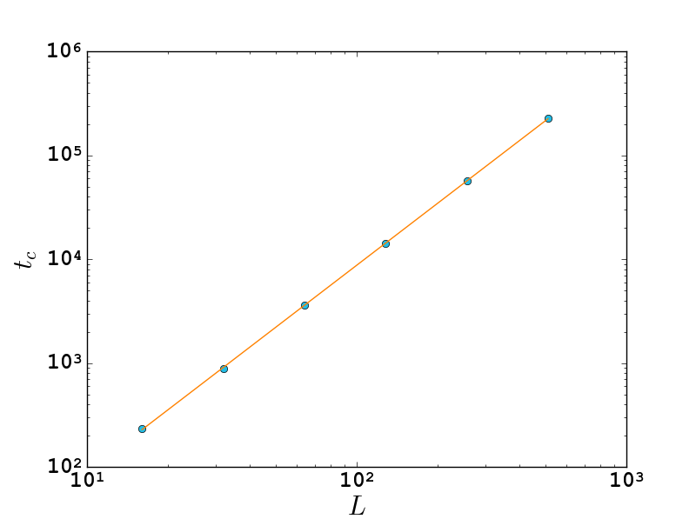

Figure : A log-log plot showing the relationship between the cut-off time and system size. From this data, the gradient of the line is given to be 1.98, corresponding to a scaling relation of L2.

### Height Data Collapse

Using the scaling relations calculated in Section 4.1.1, a data collapse can be produced for the system sizes. This data collapse allows the intrinsic nature of the model to be extracted.

Using a smoothing function, with a smoothing factor of 100, Figure 4 was produced, displaying the data collapse for all system sizes. It is seen that for small system sizes, the data collapse does not perfectly work, most notable for L = 16. The smaller system sizes require a correction to scaling, which is discussed in Section 4.1.3.

For the data in Figure 1, the only variable between the data sets is L. Therefore to perform a data collapse, this L dependence had to be removed. As it was previously 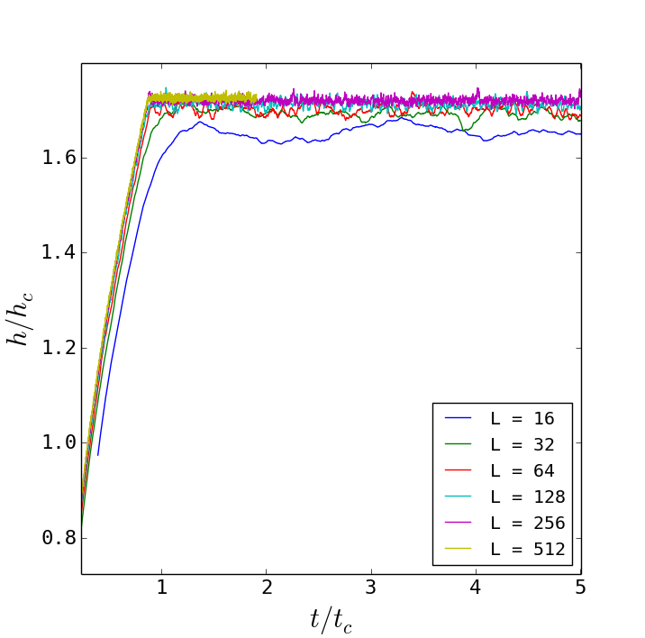found that hc scaled with L and tc scaled with L2, by dividing the height and time by their critical values for each system size, the data collapse was produced. Expressing this mathematically, the following is obtained:

$$F:\tilde{h}\left(t;L\right)= L F\left(\frac{t}{L^{2}}\right)$$

where $\tilde{h}\left(t;L\right)$ is the smoothed data and $F$ is the scaling function. The data collapse shows that the scaling function behaves differently for small arguments (t < tc) and large arguments (t > tc). By splitting the data plotted before and after tc, it is found that the scaling function follows the following relationship:

$$F\left(\frac{t}{t_{c}}\right)= \left\{\begin{aligned}α/{L } for t< t_{c} \\ α for t> t_{c}\end{aligned}\right.$$

where $α$ is a constant related to the maximum height of the system. During the recurrent configurations, it is clear that height of the system stays constant, as well as the slope of the function. Therefore for large arguments, the scaling function must be a constant for all system sizes.

The data shows that, although there is no system size dependence during the transient, there is time dependence. From Figure 1, the fitted line showed that the height during the transient increased as a power law proportional to t0.5. Comparing this to Equation 3 for t < tc, we find this to be valid, as tc has an L2 dependence, so the transient region will have a root L2 dependence that needs to be divided out.

### Corrections to Scaling

The average height was previously shown, in Figure 2, to vary linearly with the system size. The average was calculated using Equation _ from __. The data collapse in Figure 4, smaller system sizes do not completely conform to this relationship. This is not obvious from Figure 2, thereofre to see this discrepancy more clearly, using Equation 2, the average slope was plotted. From the data collapse, the average slope is shown not to depend on the system sizes, so all the systems should collapse to the same average. This is presented in Figure 5.

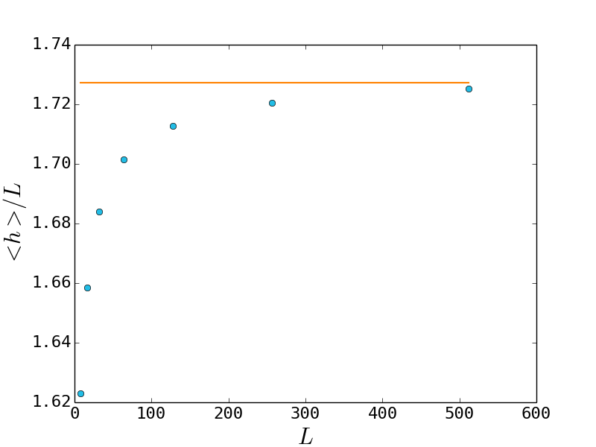

Here the data shows that correction to scaling is required, as the average slope only tends to the true value for increasing system size. To obtain an initial estimate of the scaling relation, given by the orange line, data points within 10% of the average slope were taken into account, and produced a new gradient value of 1.727.

A correction to scaling formula was then adopted to more accurately find the scaling relation, and is given in Equation 4.

$${〈h(t;L)〉}_{t}=a_{0}L(1-a_{1}L^{{-ω}_{1}})$$

where $a_{0}$, $a_{1}$ and $ω_{1}$ are constants. By some manipulation, the following equation can be obtained, and used to find $a_{0}$ and $ω_{1}$ using optimization.

$$\log\left(a_{0}-\frac{h}{L}\right)=\log\left(-a_{1}\right)+\log\left(a_{0}\right)-ω_{1}\log{(L)}$$

Setting the initial value of $a_{0}$ to 1.725, around the value for the $a_{0}$ estimate, the measured values of were fitted using Equation _ whilst incrementing $a_{0}$ by 0.001. The optimized values of $a_{0}$ and gradient $ω_{1}$ were returned when the residual fit of the data was at a minimum. The optimized values returned for the data were $a_{0}=1.733$ and $ω_{1}$ = 0.60. However, the extent of correction is unsure as they may be

The standard deviation of the average heights were also calculated using a standard formula given by Equation _ from __. Plotting the data on a log-log scale produced a scaling relation of L0.24, and is presented in Figure 6. By transforming the data in the same way as the average height, however, from Figure 7, there is no obvious correction to scaling present.

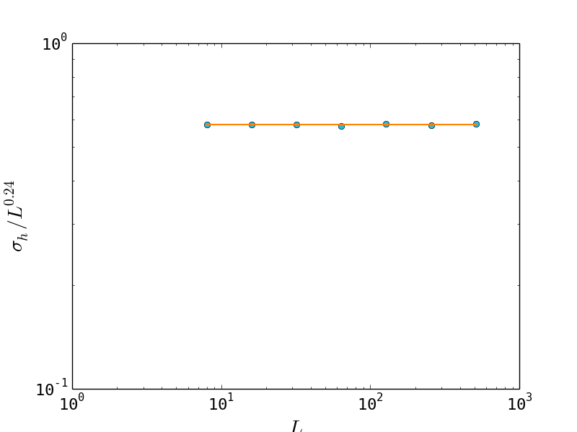

The average slope is given by Equation 1. Combining this with Equation 5, the following relation is obtained:

$z\left(t;L\right)=\frac{{〈h(t;L)〉}_{t}}{L}=a_{0}(1-a_{1}L^{{-ω}_{1}})$

As L tends to infinity, the L term on the right most side of the equation disappears, leaving the average slope to tend to a0. This is what we find for large system sizes in Figure 5.

When p = 0.5, an equal number of slope thresholds of 1 and 2 are expected, so the average height would be expected to take this into account and settle at an average of 24 for L = 16 and 48 for L = 32. However this is not the case. This can be explained as for slopes with a gradient of 2, they are less likely to be changed as they can sustain two grains before collapsing, therefore lasting a longer time before collapse occurs.

Using propagation of errors for standard deviation, the following equation for the slope standard deviation is also obtained as:

$$σ_{z}=\frac{dz}{dh}σ_{h}∝ \frac{L^{0.24}}{L}$$

Therefore as L tends to infinity, the slope uncertainty tends to zero.

### Height Probability Data Collapse

To calculate the distribution of heights at steady state, the height probabilities were calculated and plotted in Figure 8. Here, the peak probability of the height decreases as the system size increases, and the mean values and standard deviation values increase, as expected. By applying the central limit theorem, the peaks can be approximated as Gaussian. Therefore, each peak can be represented by the probability distribution:

$$P\left(h\right)= \frac{1}{σ_{h}\sqrt{2π}}e^{-\frac{(h-〈h〉)^{2}}{2{σ_{h}}^{2}}}$$

By using this approximation, each peak can be standardised into one Gaussian peak with a mean of zero and a standard deviation of one. This can be achieved for each system height by substituting the values calculated in Section 4.1.3 into the Equation _. Expressing this mathematically, by multiplying Equation _ by $σ_{h}$ for each system size, and transforming the exponent of the exponential to:

$$y= \frac{(h-〈h〉)}{σ_{h}}$$

the plot in Figure 9 was obtained, showing the height probability data collapse. However there is some skew evident in the plots, namely a greater range of height frequencies occurring above the mean value compared to below it giving the curve a larger tail on the right-hand side. This can be explained when considering how the model favours a gradient of 2 rather than 1. This means that there is a greater chance for the height to be greater than the mean, therefore have a larger than average number of slope thresholds set to two, than below it, where a larger number are set to one.

## Oslo Model Avalanche Size

The avalanche-size is equal to the number of relaxations in the system upon addition of a grain. For all the tasks that follow, the system had reached the attractor of the dynamics.

### Avalanche-size probability

To calculate the size probability, Equation _ from __ was used. The data was first processed using into log bins before being plotted. The method as to how the data was binned can be found from __.

Before the plotting data for all system sizes, the bin size multiplication factor, a, was tested to optimize for the number of data points being sampled in the bins. Figure _ presents the data for N = 104, 106 for a fixed a of 1.4.

Overall, as the number of data points increased, the data became better defined, so the key features can were seen. Here the notable features of the graph are a smooth power law decay in probability before reaching a ‘bump’, where after the probability decays sharply. The bump relates to the dropping of grains out of the system. The unprocessed data is shown to be discrete for lower probabilities, due to the fact that there are only a finite number of grains added to the system. Therefore, the probabilities take discrete values for avalanche sizes with the same frequency.

As N tends to infinity, the probability distribution will tend to a smoother distribution, therefore a large enough N has to be used, to get an accurate representation of the distribution. For this paper, an N of 106, was used, allowing the use of a larger bin size of a = 1.4. The bin size is important, as a sufficient number of values are required in each bin to define it to avoid the appearance of fluctuations, however too large bins means that the plot will become too smoothed.

Figure _ presents the avalanche size probability plotted for the system sizes with settings of N = 106 and a = 1.4. The same power decay law is followed by all system sizes, and all systems present a bump, where after the probability sharply decays. There is no typical avalanche size, however all systems show a cut-off, or maximum, avalanche size, which increases with system size. Fluctuations appear at smaller avalanche sizes as, given the logarithmic nature of the plot, any discrepancy is amplified.

### Finite size scaling ansatz

To check if the data follows the finite size scaling ansatz, the following scaling forms of the cut off avalanche size and the probability can be assumed:

$${\tilde{P}}_{N}\left(s;L\right)∝ s^{-τ_{s}}G(s/{L^{D}) for L≫1, s≫1}$$

where ${\tilde{P}}_{N}\left(s;L\right)$ is the avalanche-size probability for finite N, $τ_{s}$ is the avalanche-size exponent, $D$ is the cut-off avalanche size and $G$ is the scaling function. If Equation _ applies, upon finding the critical exponents $τ_{s}$ and $D$, the data should collapse onto one curve.

To estimate $τ_{s}$, the gradient of the probabilty decay can be taken. Using the fit presented in Figure *,* an estimate for $τ_{s}$ was found to be 1.55. To estimate $D$, cut-off avalanche was measured from the data and plotted on a log-log plot against system size. The gradient of this graph gave the value of $D$, measured to be 2.21. Using these estimated values, a data collapse was successfully produced and shown in Figure __.

To mathematically check these values, the scaling relation of the critical exponents was derived. Starting with the kth moment of the avalanche-size is given by:

$$〈s^{k}〉= \sum_{s=1}^{∞}{s^{k} P(s;L)}$$

where $P(s;L)$ is the probability distribution given an infinite L. Using the finite scaling ansatz in Equation __ and assuming it is valid for all $s$ greater than zero, the sum can be approximated as an integral, resulting in the following:

$$〈s^{k}〉∝ \int_{1}^{∞}{s^{k-τ_{s}}}G(s/{L^{D}) ds}$$

Substituting in $u=\frac{s}{L^{D}}$ the following is obtained:

$$〈s^{k}〉= \int_{1/{L^{D}}}^{∞}{{\left(uL^{D}\right)}^{k-τ_{s}}}G(u)L^{D}du$$

Finally, the form of the moment with respect to system size is given by:

$$〈s^{k}〉= L^{D(1+k-τ_{s})}\int_{1/{L^{D}}}^{∞}{u^{k-τ_{s}}}G(u)du$$

where, if $1+k>τ_{s}$, the integral will converge to a constant, as the scaling function decays sufficiently rapidly.

Using Equation _, and the fact that the mean avalanche-size (i.e. k = 1) should be equal to the system size, we know that:

$$D\left(2-τ_{s}\right)= 1$$

Substituting the estimated values into the left-hand side of Equation _, a value of 0.99 is obtained, thereby largely satisfying Equation _.

### Moment Analysis

Another method to extract the values of $τ_{s}$ and $D$ can be done through moment analysis where the k-th moment of the avalanche size is calculating using Equation 11 from __.

By assuming the finite-size scaling ansatz in Equation_, the kth moment is expected to scale as $L^{D(1+k-τ_{s})}$. This means that if the kth moments were plotted against L on a logarithmic scale, the gradient should be linear and correspond to $D(1+k-τ_{s})$. This relationship is shown in Figure _.

To find the values of $τ_{s}$ and $D$, the five values of $D(1+k-τ_{s})$ were plotted against each corresponding moment, resulting in a linear relationship presented in Figure _. The value of the gradient corresponded to D = 2.22 and the line intercepts the x-axis at ($τ_{s}-1)$ corresponding to a of $τ_{s}$ = 1.55. These values when substituted into Equation _ return 0.999, approximately satisfying it. There is a larger discrepancy in this method compared to the first. Fitting larger sy

# Conclusion

The Oslo Model was implemented to study self organized criticality. The height of the system was studied as a function of time and system size. It was found that the critical time between transient and recurrent configurations scaled as L2 whilst the average height was proportional to L. Using this a data collapse was produced. Corrections to scaling were present and the height probability was also data collapsed.

The avalanche sizes were also measured and tested to see if they followed the finite scaling ansatz. The final values of tau and D extracted were 2.22 and 1.55, corresponding to the finite scaling and successfully producing a data collapse. This was achieved using the moment analysis, although there were corrections to scaling present.

Overall the model displayed self organized criticality and data collapses were achievable with the data.

# References